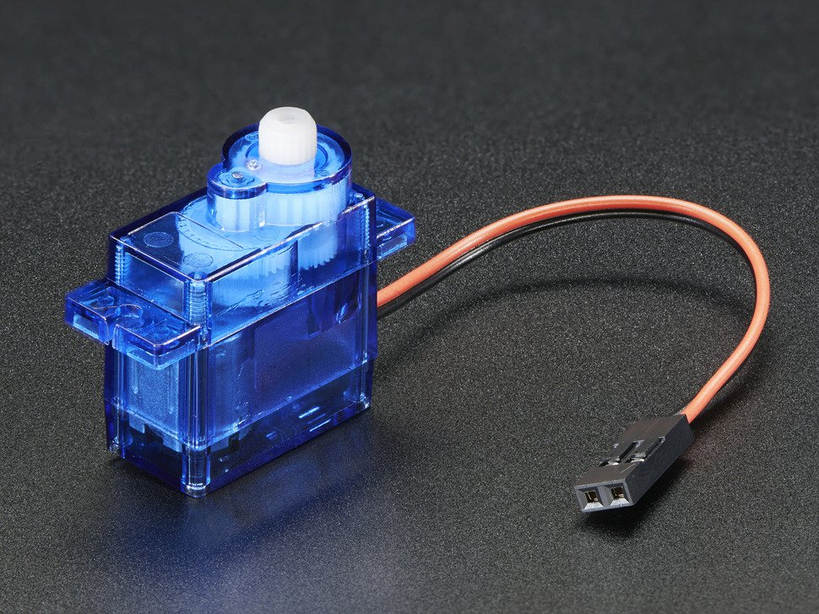

# **DC Motor in Micro Servo Body**

This tiny **DC Motor in Micro Servo Body** is an interesting motor - it's the same size and shape as our micro servo but it *isn't* a servo. It's more like a DC motor + plastic gear-train in a box. It's not a super powerful motor, it would do well as a little robot wheel. It's also a lot less expensive than a micro servo (continuous or non-continuous) because there is no control board inside. Controlling speed is done by PWM'ing the power leads, controlling direction is done by swapping the power polarity - just like any brushed DC motor.

Runs from 4-6VDC, we've powered it with a Lipoly and 3 alkaline, or 4 NiMH batteries with success. You cannot control this directly from a microcontroller pin! You must have a H-bridge such as a [L293D](https://www.adafruit.com/products/807), [TB6612](https://www.adafruit.com/products/2448) or a [Motor shield](https://www.adafruit.com/products/1438), [Motor HAT](https://www.adafruit.com/products/2348) or [DC Motor + Stepper FeatherWing](https://www.adafruit.com/products/2927).

Motor comes with 2x screws and 2x nuts for mounting to a chassis. **No flanges or horns included** - [it's intended to mate with our little wheels, there's a screw to attach once they're plugged together](https://www.adafruit.com/products/2744). Build a robot vehicle of your own with these little motors driving it!

# **TECHNICAL DETAILS**

* Dimensions: 32.3mm x 12.3mm x 29.9mm / 1.3" x 0.49" x 1.2"
* Spline Count: 21
* Weight: 8.4g
* No load speed: 110RPM (4.8v) / 130RPM (6v)
* Running Current (at no load): 100mA (4.8v) / 120mA (6v)
* Peak Stall Torque (4.8v): 1.3 kg/cm / 18.09 oz/in
* Peak Stall Torque (6v): 1.5 kg/cm / 20.86 oz/in
* Stall Current: 550mA (4.8v) / 650mA (6v)
* [Datasheet](https://cdn-shop.adafruit.com/product-files/2941/FM90%20specs.pdf)